10 tips to build bridges, not just profiles on LinkedIn

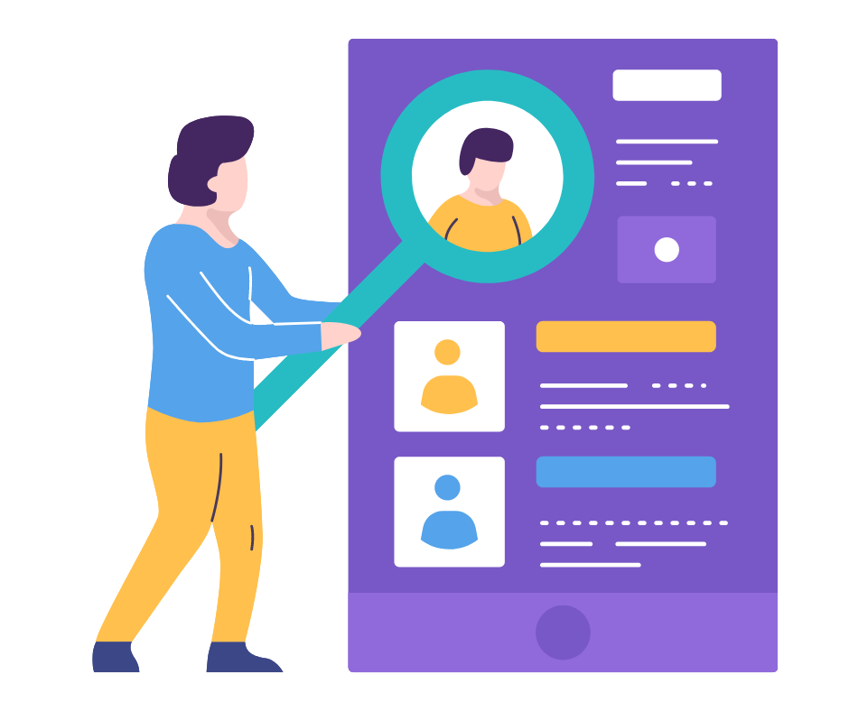

LinkedIn may not be the biggest network with the largest reach but if you are here for personal branding or your brand building, it's an essential place to be. With over 700 million users worldwide, it is the perfect place to network & grow professionally.

Building a strong LinkedIn profile is crucial for professional networking & career advancement. It is crucial to include your LinkedIn profile link to your resume & that is why, just having a LinkedIn profile is not important, but success lies in crafting your profile in such a way that it attracts the attention of business professionals, hiring managers & potential prospects. Here are 10 LinkedIn profile tips for job seekers & recruitment specialists that can help achieve that level of success.

Tips for professional growth
Profile Picture
Your profile picture plays a very important role for your LinkedIn presence. According to research, creating a LinkedIn profile picture builds trust & your profile is more likely to be viewed by people.

You should make sure your profile picture is up to date so that nobody can question your credibility. A high-resolution image with the right expression that makes you look approachable can make a good first impression on the viewers.

Background photo
A good background image for your profile can make you stand out from the crowd & take your brand to the next level.

According to Shashank Shalabh, CEO of Omnidigit, “Your background image is a perfect place to highlight social proof or achievements. LinkedIn is all about branding. With the right messaging, both visual & text, you can create a better impression.”

So, blending in that perfect background photo is one of the keys to building great connections.

Headlines
Along with playing a role in the LinkedIn algorithm & making you rank higher; a compelling headline entices hiring managers or visitors to visit your profile. They are convinced that you can provide great value to them as the headline provides an overview of your skills & achievements.

Your headline should be concise yet descriptive, inclusive of appropriate keywords & updated regularly.

Summary
This 2000-character section appears under your name & headline. Most people overlook this section, but this is one of the main elements of your page.

It can best describe you, your experience & your passion. Crafting a compelling summary is an art as it gives you a chance to showcase your personality & expertise.

Skills
This section plays an important role in shaping your profile page to best suit the requirements of your potential prospects or hiring managers.

Listing out the relevant skills can highlight your expertise & make you rank higher when searched for it.

Connections
A strong network of connections provides you with more job opportunities & new business opportunities. It increases your credibility & leaves the impression of active engagement on your profile.

All this in turn increases your visibility, which can help you build your personal as well as professional brand.

Content
Creating engaging content on LinkedIn can help you establish yourself as a thought leader & expand your professional network.

You can share industry insights, tips & advice, success stories & interactive content to engage with your audience.

Recommendations
LinkedIn recommendations help to build your online brand & enhance your professional reputation thus advancing your career. They serve as social proof for all your skills & capabilities.

With the help of these recommendations, you can grow your network & reconnect with former colleagues or clients.

Follow interests
Following your interests helps you to stay informed & grow your network. It provides a great way to discover ideas, insights & knowledge by industry experts which allows you to develop yourself professionally & build your brand.

Improvements
To demonstrate consistency, it's important to update your profile with new information regularly.

This also shows that you are continuously growing & learning, & this attracts employers or prospective clients to your profile.

Conclusion

LinkedIn profile building can be tedious if you try to do everything on your own. Fortunately, there are tools that can help you with LinkedIn profile optimization & LinkedIn careers.

PaintMinds is one such tool that comes to your aid. With our team of experts & career mentors who have worked on 100+ professional profiles, build your profile to align with the latest industry trends as well as your personal expectations. Visit the PaintMinds website to bring on a revolution.

Keywords- LinkedIn profile optimization | Creating a LinkedIn profile | LinkedIn profile | LinkedIn careers | LinkedIn profile link | LinkedIn profile tips for job seekers

Title Tag – Build your LinkedIn Profile from scratch – The way to success!

Meta Description – Do you want to aim high towards professional growth? This blog will give you the recipe to success to build your LinkedIn Profile.

Meta Tag – LinkedIn Profile tips for Professionals | PaintMinds

